**Task 2: Use ORM to setup database structure and relationships....and do CRUD operations also**

Books and Author are used to setup database.

Under Myprojects

Settings.py we add myapp on installed app so that an app is created.

* First Models are set in Models.py having class Author and Books.
* Views.py are setup to retrieve it in url as homepage, author_list and author_detail
* Admin.py is setup to see it in Django admin panel as admin.site.register(Author, Books)
* Under urls.py path to the models and views is set.

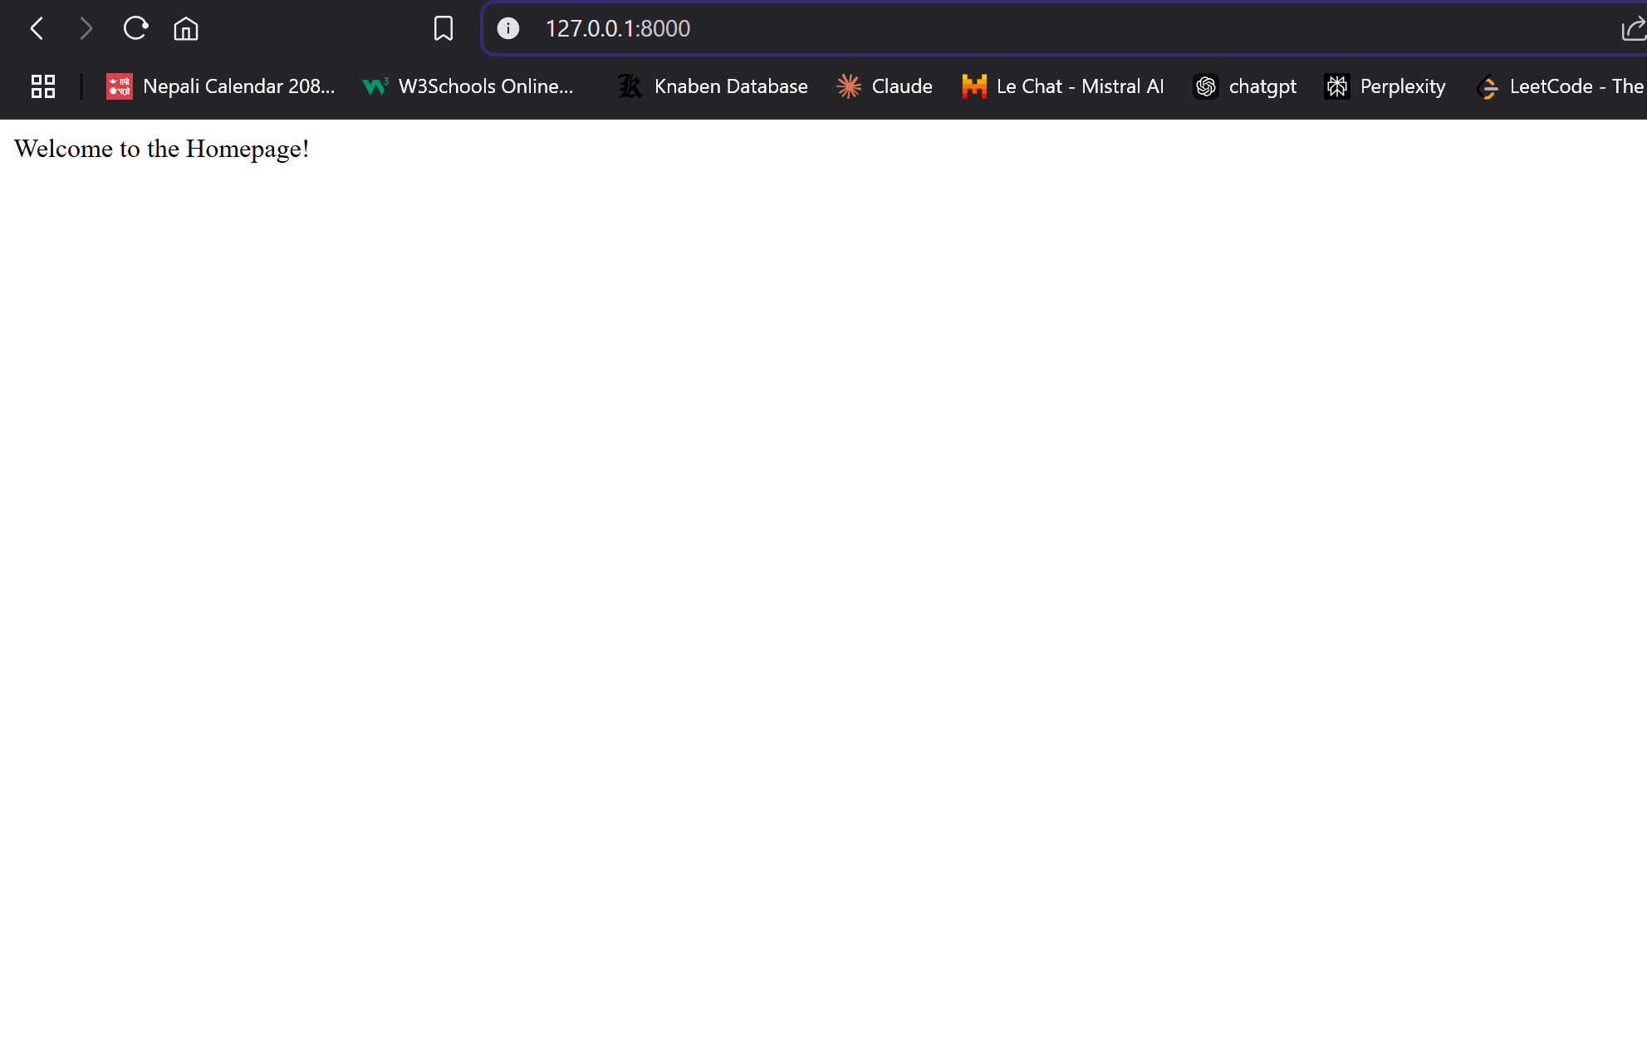

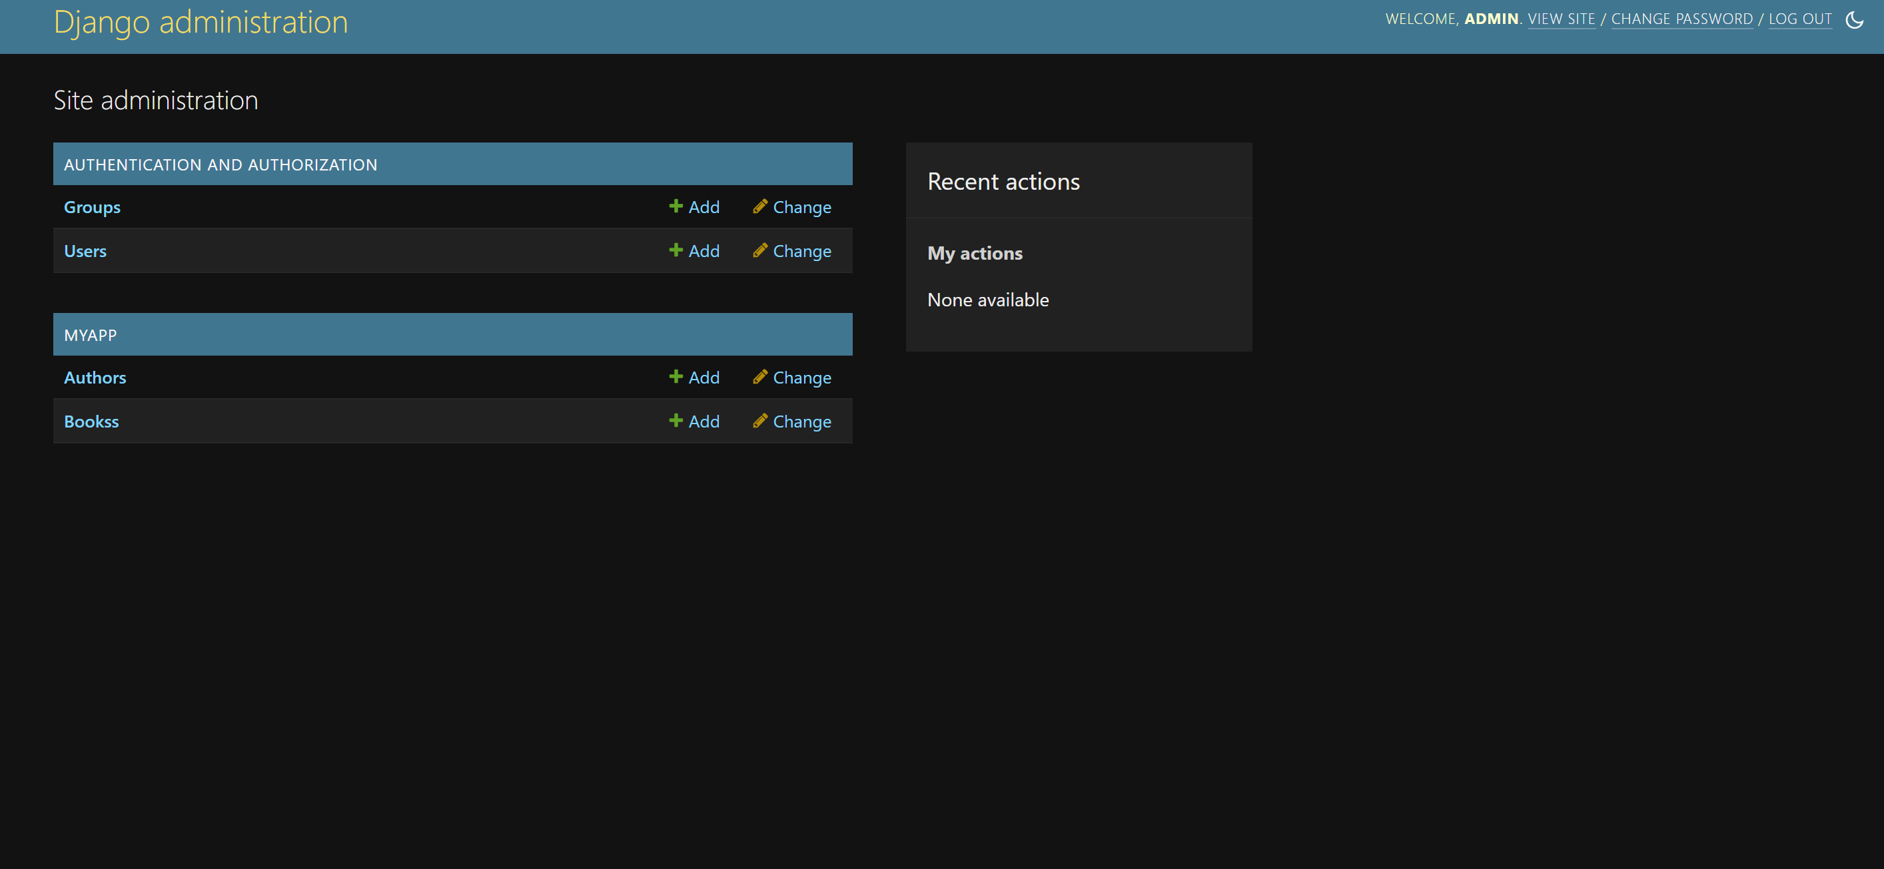

CRUD operation performed in a shell python manage.py shell.

